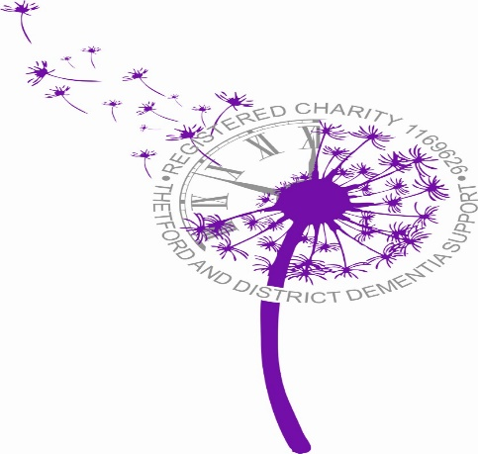

**Looking back**

What a year 2016 has been. It was a year of changes for many of us, some good, some not so good, all changing us in some way or another.

For the group this was indeed the case and we finished 2016 in our new “home” on a definite high note, with fantastic carol singing from Norwich Road School and the fabulous Discord.

We held a lovely open morning and I was deeply humbled by the many guests who came along and stayed or popped in to say “Hi” and enjoy some of the activities taking place as well as the delicious buffet.

Thanks to Tesco Thetford for providing us with food donations towards our Christmas Dinner and buffet, and thank you to Sarah Douthwaite – Tesco Community Champion who is our extra pair of hands and helper on so many occasions.

Here’s a sample of what took place..

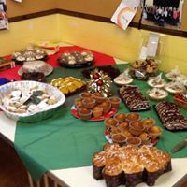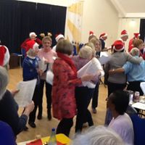

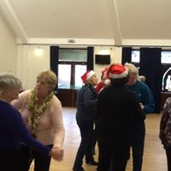 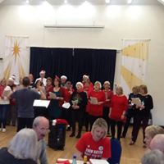 thank

Thank

TADDS Bi-Monthly Mardle

January and February 2017

Telephone: 07542 866 519

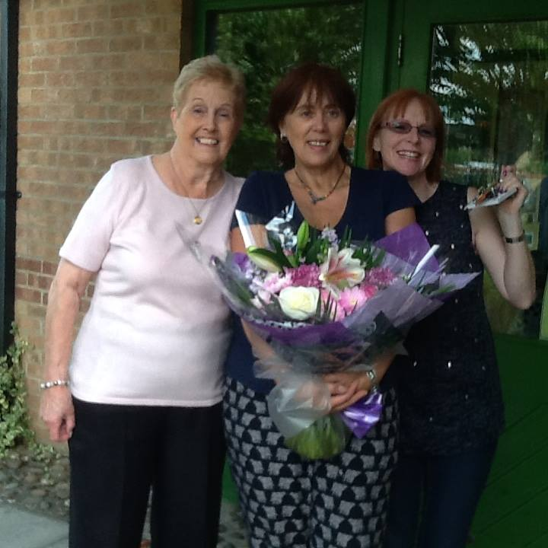

Thetford & District Dementia Support

charity registered in England & Wales:

charity Number: 1169626

**Email:** [taddsgroup@hotmail.com](mailto:taddsgroup@hotmail.com)

[www.thetford-dementia-support-group.org.uk](http://www.thetford-dementia-support-group.org.uk)

Hello everyone

Welcome to our Group Newsletter, where we hope to bring you various news and information.

If you would like this electronically, please let Jo M know and we will send this out to you.

Well it’s the start of the New Year and as they say “Out with the old and in with the new” so to kick our New Year off in style we are now showing you the lovely new logo that has been designed for us.

Thanks go to Craig, Jo C and to Jo’s daughter Holly for their input and creative flair.

It also incorporates our charity registration number, so that we can start the fundraising in earnest this year. New brochures and fundraising banners are coming.

**Looking forward**

Fundraising this year is one of our main priorities, so TADDS needs a “Funteam” for fund raising. If you think you can help us or have a couple of hours to spare occasionally to hold a collection tin or take part in our other fundraising activities, contact us on our email address.

From January onwards, TADDS is going to be running a monthly raffle to also help raise funds for us. If you have any leftover or unwanted Christmas presents that you are not sure what to do with, give them to us for our raffle. All money raised will help to support our groups ongoing costs and help local people.

**Big THANK YOU to Lakenheath Bell Ringers** for doing a fundraise for us outside Tesco in Brandon, raising £54 that’s just amazing and so wonderful of you all.

**Other project work we are doing.**

On the 16th May 2017 we will be holding a Dementia Awareness Day at the Guildhall in Thetford. This is going to also be the launch of Thetford as a Dementia Friendly Community.

If you are a local business, group or organisation that wants to be involved in the development of this, or if you are interested is helping, please let me know.

For businesses groups and organisations there will be FREE training, for your staff in recognising dementia and how to help your customers or staff who may be living with dementia.

If you can do no more than spread the word of what we are trying to achieve, TADDS would be grateful.



**We are launching our very own**

**DIY SOS**

Our lovely new venue needs a more up to date kitchen. We are currently working closely with Cloverfield Community Church to hopefully source some funding to get this project off the ground.

If you have funding ideas or want to help in a practical way, or if you know a business or person who would be useful in their help with this please put us in contact with them.

We need the community to help us reach our goal on this one and all help would be appreciated.

**About us:**

If you would like to get involved in our group as a volunteer, please email us on [taddsgroup@hotmail.com](mailto:taddsgroup@hotmail.com) or ring our mobile 07542 866 519 – you can also message us through facebook.

If you would like to come to our group to find out more about dementia or to get support with a diagnosis, please come along to group on a Friday from 10am until 1pm. No formal referral is necessary.

More exciting news to follow in March..

